Objectives

The principal objective of this lab was to gain experience in the use of the function generator, power supply, multimeter and oscilloscope. Secondary objectives included reviewing techniques and procedures for professional laboratory work and the preparation of the materials needed for the labs for the remainder of the semester.

Procedures

Prelab

Initially, the theoretical output of the physical circuits were calculated by hand before the lab. This provided a baseline and provided a means to confirm that the equipment was functioning properly.

Physical Experiments

1. Using a BNC cable, the signal output from the function generator was connected to CH1 of the oscilloscope. Adjustments to the amplitude, offset, and frequency knobs were made until the wave displayed matched that given in prelab exercise 1. After pressing the measure button, the values were given as follows: frequency: 1.007KHz, peak-to-peak: 3.72V, average: 394mV
2. 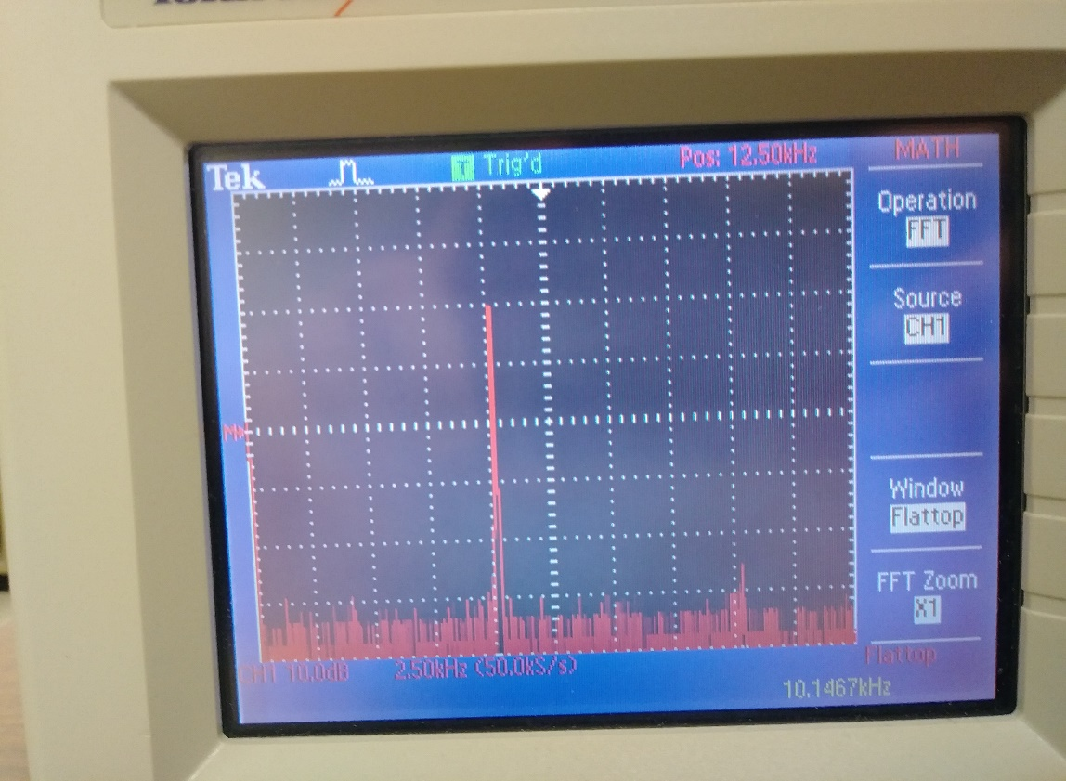Pressing the Math button and setting the operation to FFT displays the fast Fourier transform of the input signal. Adjusting the second/Div to 50kS/s and the Volts/Div to 10dB allowed the peaks of the FFT signal to appear. The peaks of this signal were at 100Kz, 10.2KHz and 20 kHz. See fig 1

Fig 1. FFT of 10kHz sin wave

When the output from the function generator is changed to square waves (fig 2) or triangle waves (fig 3) the number of peaks increased.

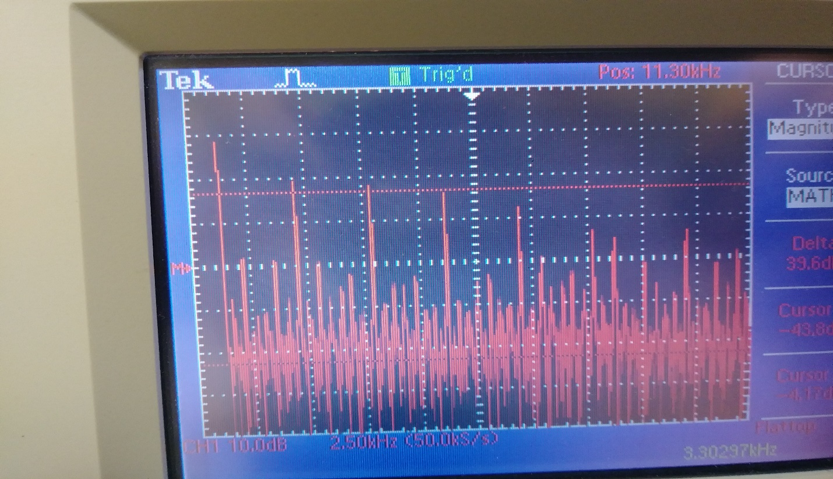

Fig 2. Square wave FFT

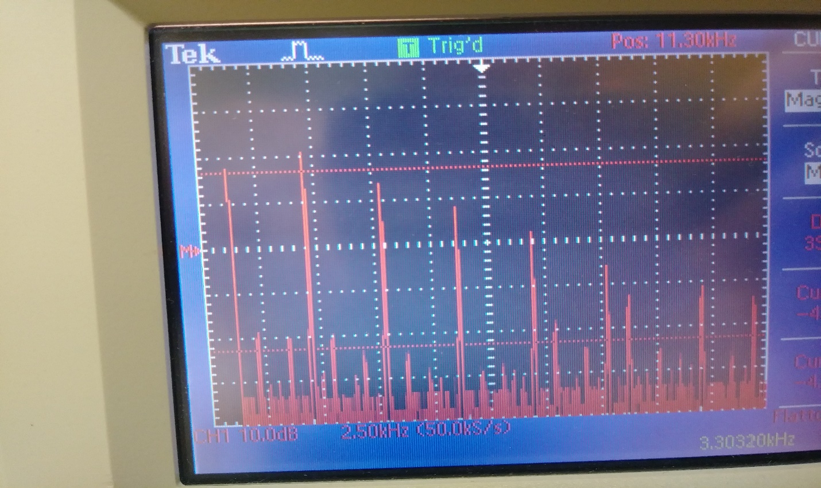

Fig 3. Triangle wave FFT

1. Set up circuits from the prelab and display V-in and V-out on different channels of the oscilloscope.

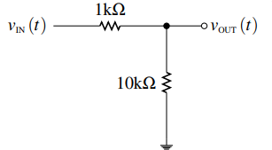

* 1. For the circuit from prelab exercise 2 (above) the peak-to-peak valtage of V-in was 3.84v, while V-out was 3.36 V. meaning that it was simply a voltage divider as predicted.

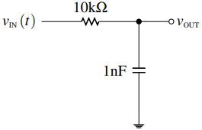

* 1. For the circuit from prelab exercise 3 (above), the output produced a peak at 1Khz. Setting the magnitude cursor to 3 dB below the peak and increasing the frequency revealed that the cutoff frequency is 14.99 kHz as predicted

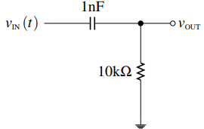

* 1. Repeating the procedure from part b on the circuit from exercise 4(above) revealed that the cutoff frequency was 7.7 kHz

1. Digital oscilloscopes work by taking discrete samples. Increasing the frequency up to 200kHz causes the FFT peak to drift backwards(lower) on the spectrum because the sample rate is lower than 2 times the frequency of the wave which causes aliasing or in other words it causes the oscilloscope to read a lower frequency due to its sampling limitations.

Conclusion

The oscilloscope was used to measure the input and output voltage of the circuits given from prelab exercises 2 through 4. Using the FFT function on the math menu measurements of the magnitude and frequency of the signal can be made. Using these tools, it was discovered that the circuits do indeed follow the predicted cutoff frequencies and expected output magnitudes.

One experimental flaw lies in the oscilloscope, it has hardware limitations which cause signal aliasing on input frequencies above 100 kHz. While the results of an experiment are only as reliable as the equipment used to take the readings, this oscilloscope was sufficient to provide the proof that the calculations in the pre-lab do in fact verify the results found in the experimental portion of this lab.